# ***Challenge Name :- Simple Webapp***

**Description:** After facing challenges, I successfully developed a web application. However, I'm uncertain why I opted to host it on Linux

**Level:-** Medium

**Solution:**

To solve the challenge we have to perform Linux commands but not common linux command.

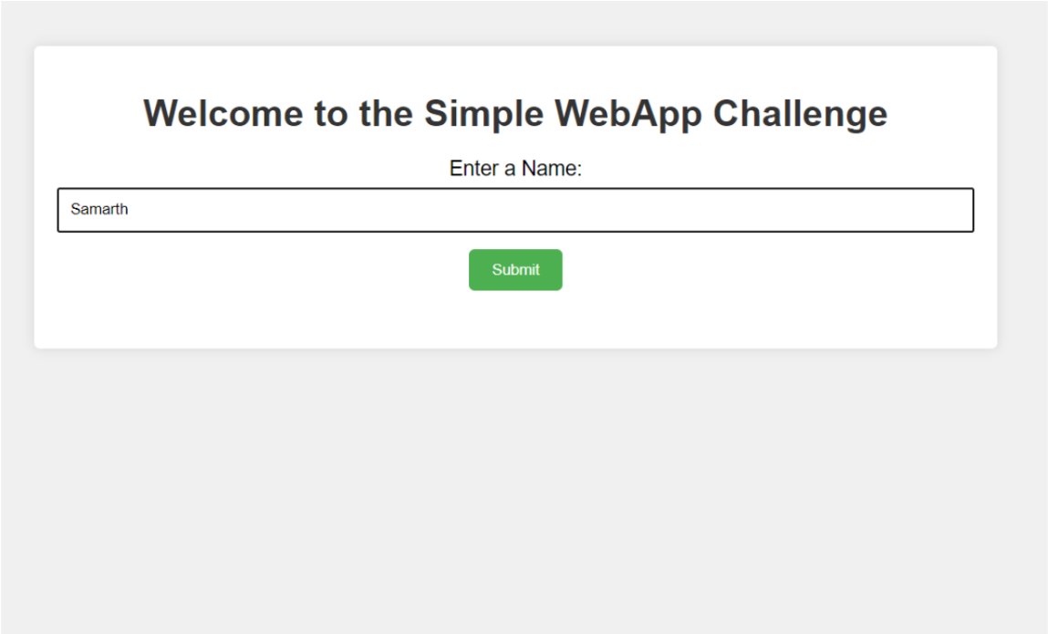

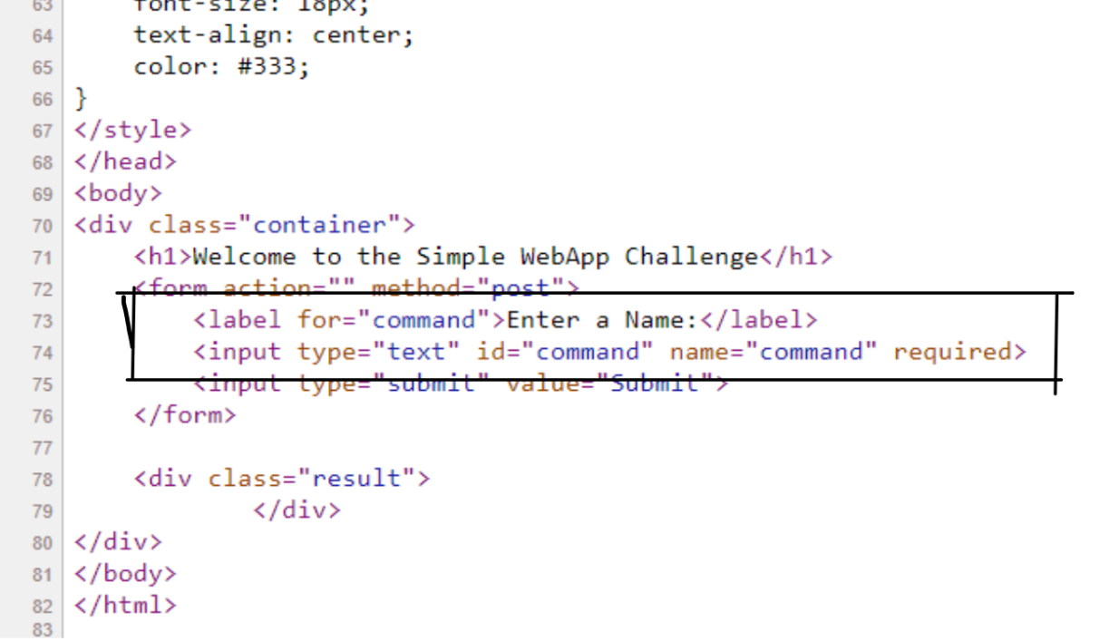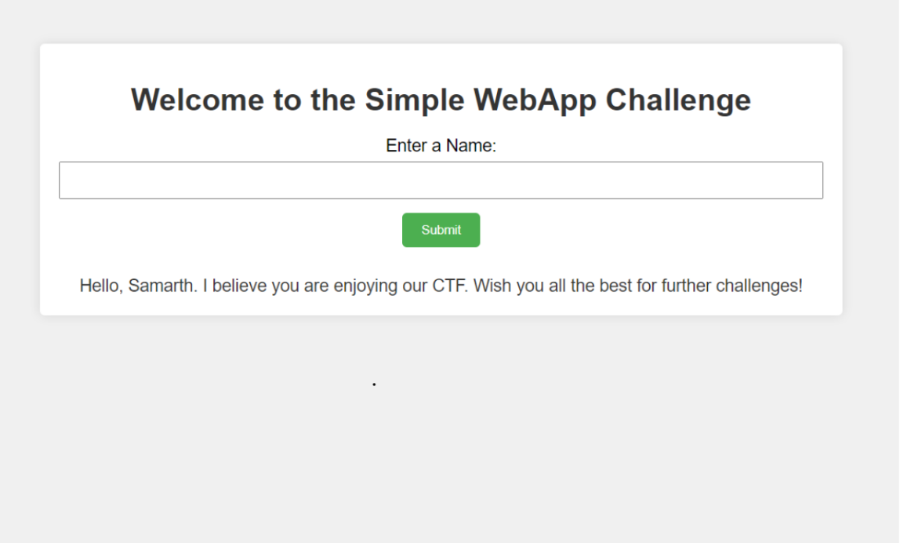

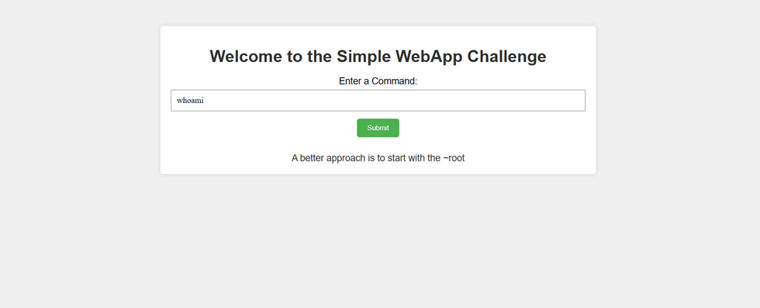

2). Lets try common ls command

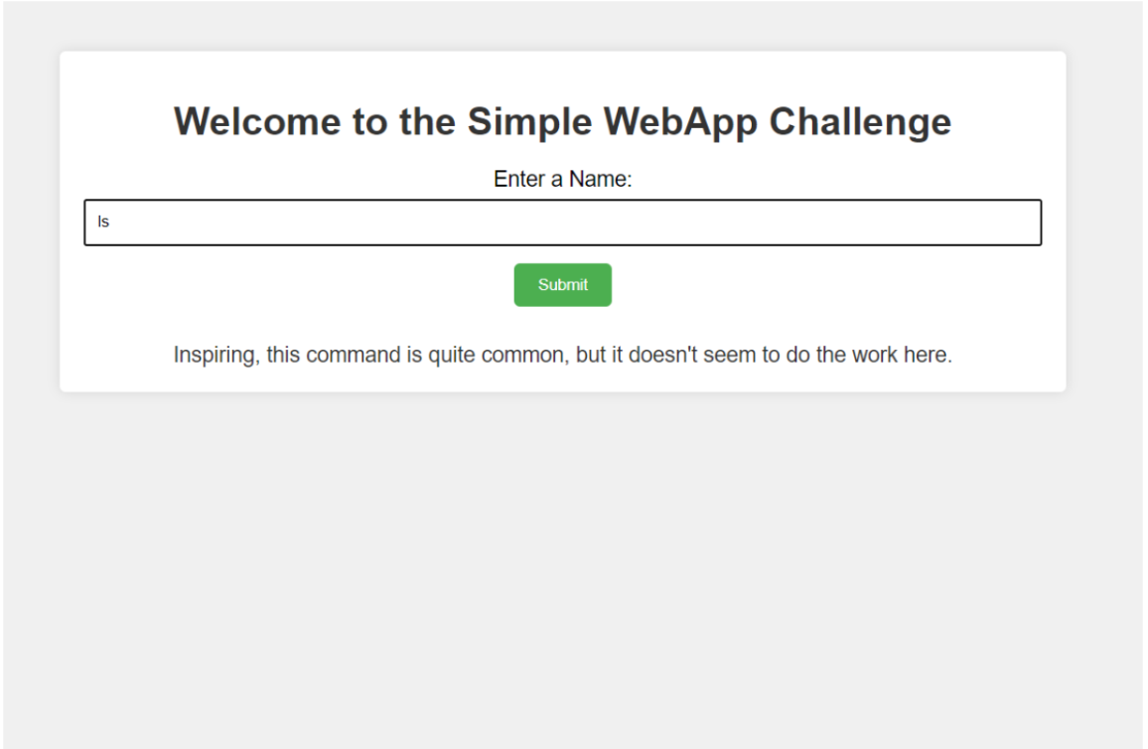

3) Using echo * command to list all files and directory

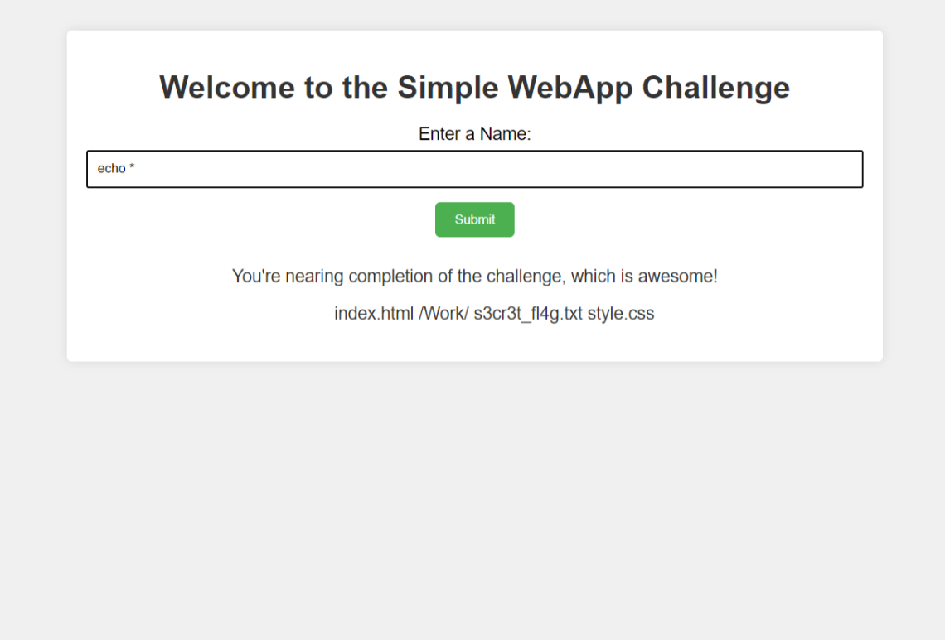

4) Use batcat to get the flag.

**Flag : flag{L1nux_c0mm4nd5_4r3_Aws0m3}**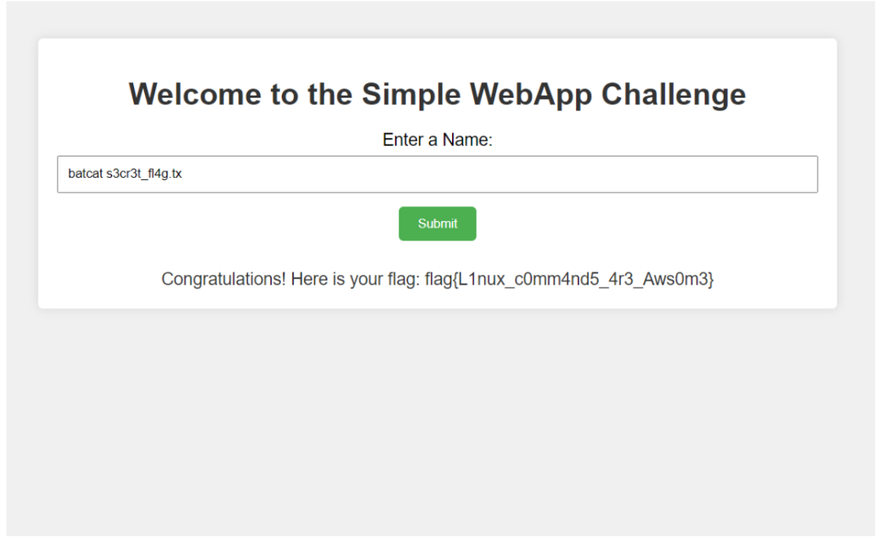

This page is intentionally left blank